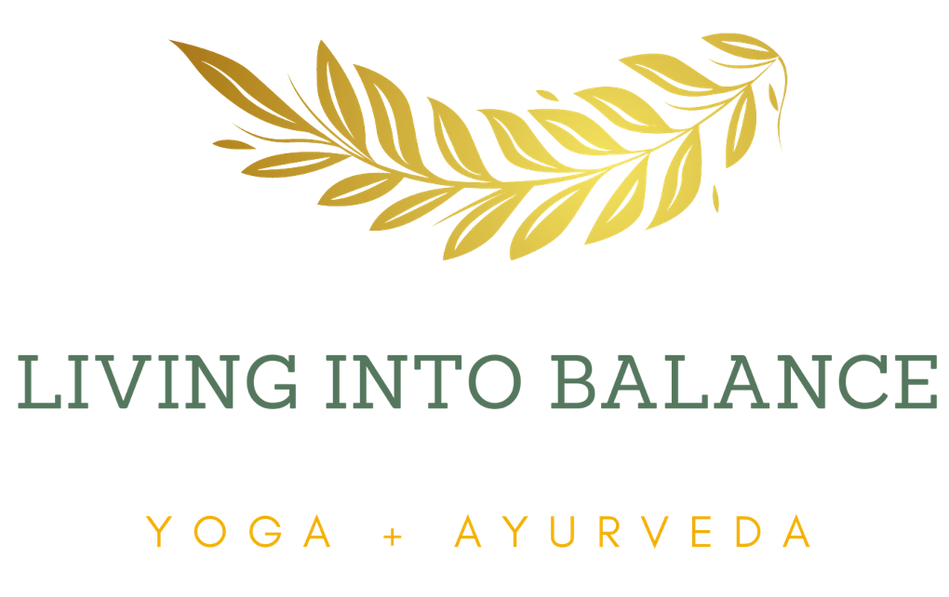

YOGA IN CABO RETREAT
February 5 - 12, 2022

NEXT PAYMENTS:
2nd Installment of $1000 is due on or before Nov 5th, 2021
Final payment of $900 is due on or before Jan 15th, 2022

REFUND POLICY:

All monies paid beyond the deposit are fully refundable or transferable to another program as long as you cancel by Jan 5th, 2022. After Jan 5th, 2022, your money is refundable/transferable only if we can fill your space from a waiting list. If the retreat center closes due to Covid or for some other reason, all monies, including your deposit will be fully refundable/transferable less $108.

